**Day 03**

Java Simple for Loop

A simple for loop is the same as [C](https://www.javatpoint.com/c-programming-language-tutorial)/[C++](https://www.javatpoint.com/cpp-tutorial). We can initialize the [variable](https://www.javatpoint.com/java-variables), check condition and increment/decrement value. It consists of four parts:

1. **Initialization**: It is the initial condition which is executed once when the loop starts. Here, we can initialize the variable, or we can use an already initialized variable. It is an optional condition.
2. **Condition**: It is the second condition which is executed each time to test the condition of the loop. It continues execution until the condition is false. It must return boolean value either true or false. It is an optional condition.
3. **Increment/Decrement**: It increments or decrements the variable value. It is an optional condition.
4. **Statement**: The statement of the loop is executed each time until the second condition is false.

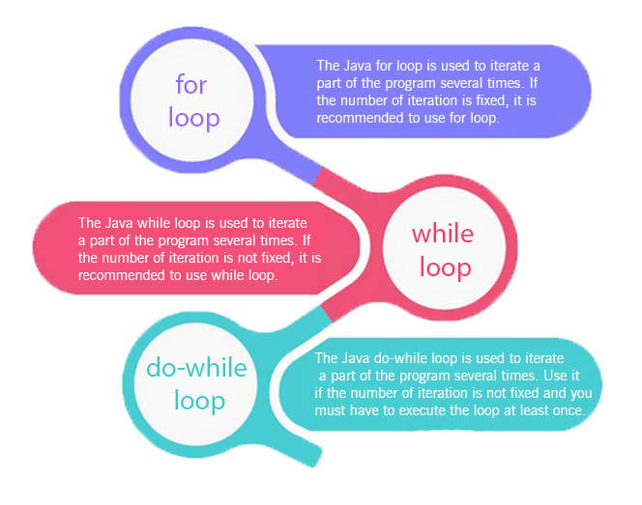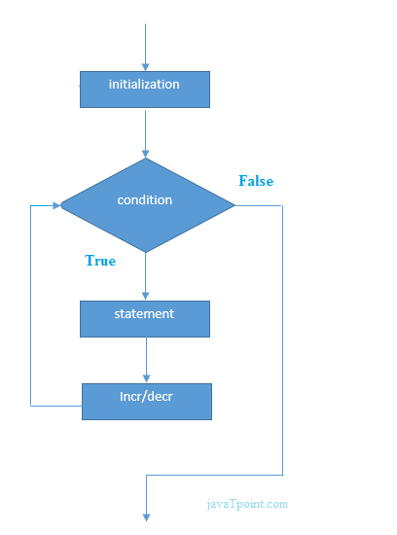

**Loops**

A loop is used for executing a block of statements repeatedly until a particular  condition is satisfied. A loop consists of an initialization statement, a test condition and an increment statement.

**For Loop**

The syntax of the for loop is  :

for (initialization; condition; update) {

 // body of-loop

}

for (int i=1; i<=20; i++) {

   System.*out*.println(i);

}

**While Loop**

The syntax for while loop is :

while(condition) {

 // body of the loop

}

int i = 0;

while(i<=20) {

   System.*out*.println(i);

   i++;

}

**Do-While Loop**

The syntax for the do-while loop is :

do {

 // body of loop;

}

while (condition);

int i = 0;

do {

   System.*out*.println(i);

   i++;

} while(i<=20);